Fiction Reading Response Menu

1.Draw and label the main characters from the story.  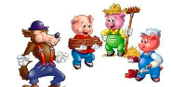  The characters in the story are______. | 2. Draw and write to tell the setting of the story.  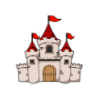  The setting is____. | 3. Create a new cover for the story.  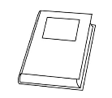
4. Draw and write about your favorite part of the story.  My favorite part of the book was ____- because____. | 5. Draw a flow map to retell story.  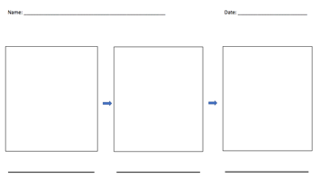 | 6. Did you like this book? Why or why not?  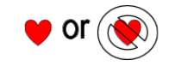
7. What was the problem in the story? How was it solved?  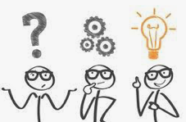  The problem was___. It was solved by____. | 8. How does the character feel? Why?  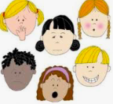  The character Feels____ because____. | 9. Draw and write about your favorite character in the story.  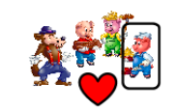  My favorite character in the book was ____ because ____.
10. Use a double bubble map to compare two characters from the book.  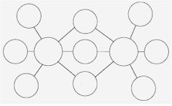 | 11. Retell the book to a family member. No writing tonight. | 12. Before reading the book make a prediction about the book.  