Non-Fiction Reading Response Menu

1.Write 3 new words you learned. Tell me what they mean.  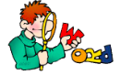 | 2. Draw and write to tell the main topic of the book.  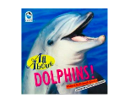  The book was all about____. | 3. Create a new cover for the book.  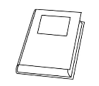
4. Draw and write about your favorite part of the book.  My favorite part of the book was ____ because____. | 5. Write and illustrate 3 new facts you learned about this topic while reading.  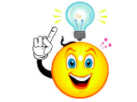 | 6. Did you like this book? Why or why not?  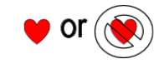
7. Before reading create a circle map listing all you know about the topic.  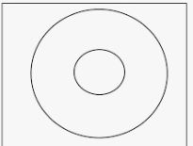 | 8. Draw and write about the most interesting thing you learned.  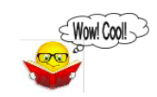 | 9. Write 3 questions you are still wondering about.  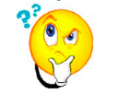
10. Do you want to read more books on this topic? Why or why not? | 11. Retell the book to a family member. No writing tonight. | 12. Draw a diagram about something you learned in the book?  